North Wind Company Report
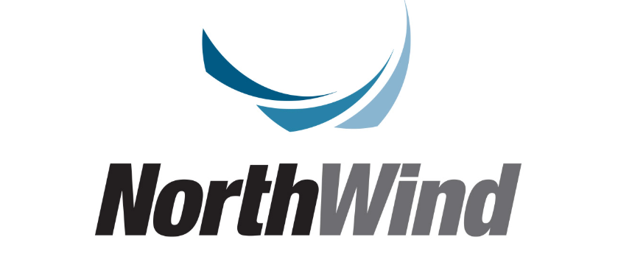

Introduction/Summary
The Northwind data analysis report aims to explore and understand the overall performance of Northwind, a fictional company specializing in food product trading. By analyzing the available data, we can extract valuable insights into sales, employee performance, customer preferences, and more. The report includes an analysis of key trends, product performance evaluation, and an understanding of customer behavior, all of which help in making strategic decisions to improve performance and drive future growth.

Scope
- Sales Performance
- Customer Behavior
- Employee Performance
- Shipping and Supplying
- Product Analysis
- Geographical Insights

Data Specs
This dataset covers a two-year period (1996 and 1998) and includes 830 orders.
The following tables were used to conduct our analysis:
- Orders Tables
- Customers Table
- Employee Table
- Shippers Table
- Suppliers Table
- Categories & Products Tables
- Regions & Territories Table

The Analysis

Sales Performance
1. What are the total orders per year & Qtr.?
2. What is the total sales amount per year & Qtr.?
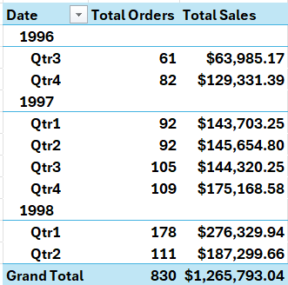
Based on the table above, Most Year & Qtr. have Sales is 1998(Qtr1).

3. What are the top 10 highest-value orders?
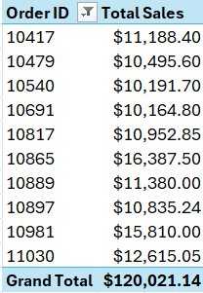
The order with ID 10417 has been identified as the highest-value order.

4. Who are the top 10 customers with the highest sales?
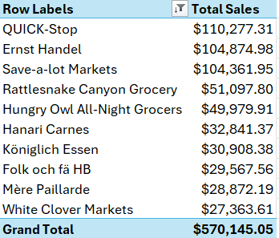
QUICK-Stop, Ernst Handel and Save-a-lot Markets These are The Top Customers with Highest Sales

5. What are the Total Sales of each category?
6. What is the Total Profit of each category?
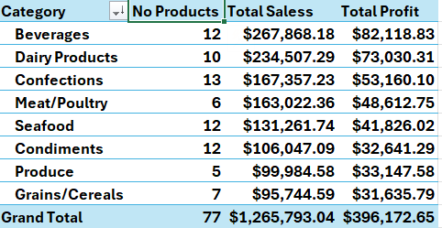
Beverages & Dairy Products Categories have the highest Sales & Profits

Recommendations:
- Focus on enhancing marketing and promotional strategies in the first quarter of each year, especially based on the success of 1998 (Q1), to boost sales during this period.
- Analyze the success factors of high-value orders (such as Order ID 10417) and apply best practices to increase the number of high-value orders.
- Implement loyalty programs and personalized offers for top customers (like QUICK-Stop, Ernst Handel, and Save-a-lot Markets) to strengthen their loyalty and increase their sales.
- Prioritize the development and expansion of the most profitable categories (such as Beverages and Dairy Products) by improving promotions and expanding product lines.

Customer Behavior
1. Who are the top 10 customers with the most orders?
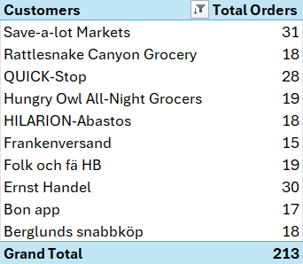
Save-a-lot Markets Company Customer Had a 31 Order, and this is the biggest Number of Orders

2. What are the countries with the most customers?
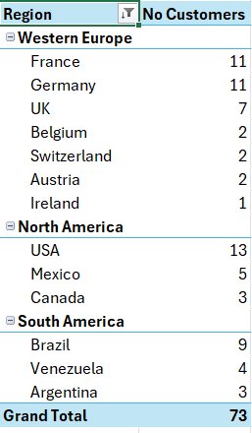
USA, France, and Germany are the countries with the highest number of customers.

3. What is the number of late orders for top customers by Sales?
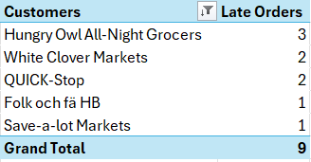
The number of late orders for top customers is not significant, but it is still essential to reduce it further.

4. Who are the customers who haven’t ordered in the last 2 years?
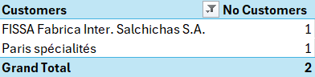
Only 2 Customers haven’t ordered in the last 2 years, this is good indicator

Recommendations
- Develop targeted loyalty programs or exclusive offers for high-frequency customers like Save-a-lot Markets to maintain their engagement and encourage even more orders.
- Focus marketing and sales efforts on these high-performing regions (USA, France, Germany) while exploring opportunities to expand into similar markets.
- For Late Orders for Top Customers:
Implement strict delivery timelines and improve logistics processes to further reduce late orders, ensuring top customers receive exceptional service.
- For Customers Who Haven’t Ordered in 2 Years:
Launch a re-engagement campaign (e.g., personalized discounts or outreach) to win back the 2 inactive customers, as reacquiring them could boost sales.

Employee Performance
1. What is the number of employees we have in each city?
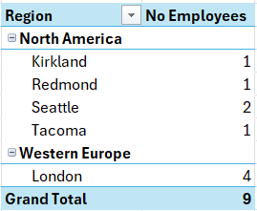
We have 9 employees in total, with 4 in London and 5 located across various cities in North America.

2. What are the total sales by each employee?
3. What is the Pg % of total orders handled by employees?
4. Which Employees Exceeded the Sales KPI Target?
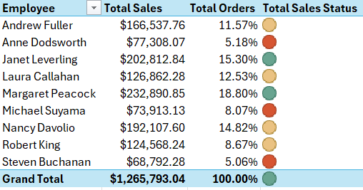
Margaret Peacock and Janet Leverling are the top performing employees in terms of sales. Margaret Peacock accounts for 18.8% of total sales, while Janet Leverling contributes 15.3% of total sales.
Additionally, other employees are performing well, such as Nancy Davolio, Laura Callahan, and Andrew Fuller.
Anne Dodsworth and Steven Buchanan have underperformed in terms of sales.

Recommendations
- Recognize and reward top-performing employees like Margaret Peacock and Janet Leverling to motivate them and maintain their high performance. Additionally, provide targeted training or mentorship opportunities for other well-performing employees like Nancy Davolio, Laura Callahan, and Andrew Fuller to help them reach the next level of sales excellence.
- Provide targeted coaching and performance improvement plans for Anne Dodsworth and Steven Buchanan to identify and address the root causes of their underperformance.

Shipping Analysis
1. What is the avg shipping cost per country?
2. What is the avg Delivery time per country?
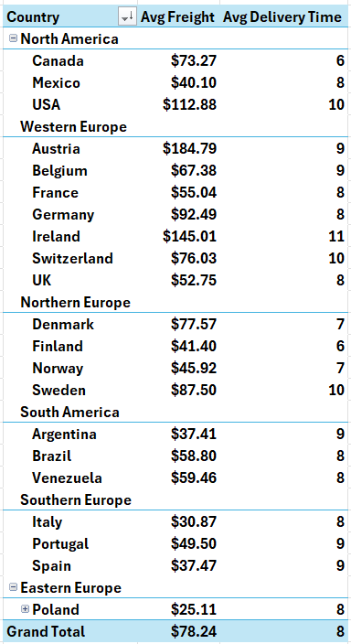
Austria, Ireland, and the USA have the highest freight costs.
Ireland, the USA, and Switzerland have the longest delivery times.

3. What are the total orders for shipping companies?
4. What is the num of late orders for shipping companies?
5. What is the Pg% of late orders for shipping companies?
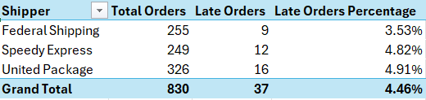
The United Package has the highest number of total orders.
However, United Package also has the latest orders, which may be attributed to its high order.
All shippers currently have less than 5% late orders, but the goal is to reduce this percentage to below 2%.

6. What is the avg Freight for shipping companies?
7. What is the avg delivery time for shipping companies?
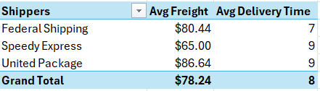
The average freight cost across all shipping companies is 78$, with United Package being the highest at 80$.

Recommendations
- For High Freight Costs (Austria, Ireland, USA):
Negotiate better shipping rates or explore alternative logistics providers to reduce freight costs in these regions.
- For Long Delivery Times (Ireland, USA, Switzerland):
Optimize supply chain routes and partner with local distributors to improve delivery efficiency in these countries.
- For Total Orders by Shipping Companies (United Package):
Leverage United Package’s high order volume to negotiate better service terms and ensure consistent performance.
- For Late Orders by Shipping Companies (United Package):
Investigate the root causes of late orders for United Package and implement corrective measures, such as improved tracking or resource allocation.
- For Late Order Percentage (All Shippers):
Set a clear target to reduce late orders to below 2% by enhancing operational efficiency and monitoring performance closely.
- For Average Freight Costs (United Package at $80):
Analyze the factors contributing to United Package’s higher freight costs and explore cost-saving opportunities without compromising service quality.
- For Average Delivery Time (United Package & Speedy Express at 9 days):
Work with these companies to streamline delivery processes and reduce the average delivery time, ensuring faster service for customers.

Supplying Analysis
1.What is the number of suppliers from each region?
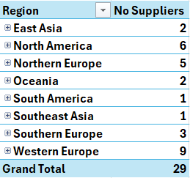
We have 29 Suppliers Total.
Western Europe has the highest number of suppliers with 9, while South America and Southeast Asia have only 1 supplier each. Increasing the num of suppliers in these regions should be a priority.

2. What is the number of products supplied by suppliers?
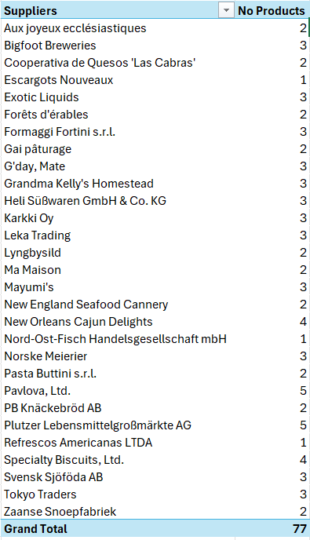
All suppliers offer a similar range of products, typically between 1 to 5 products per supplier. Among them, Pavlova Ltd and Plutzer are the suppliers with the highest number of products.

Recommendations
- Diversify the supplier base by actively sourcing new suppliers from South America and Southeast Asia to reduce dependency on Western Europe and improve supply chain resilience.
- Leverage the product diversity offered by Pavlova Ltd and Plutzer to expand your product portfolio. At the same time, encourage other suppliers to increase their product offerings to ensure a more balanced and competitive supplier base.

Product Analysis
1. What is the number of products in each category?
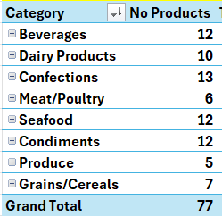
We have a total of 77 products, With the Confections, Beverages, Seafood, and Condiments categories having the highest number of products, ranging from 12 to 13 each.

2. What are the top 10 best-selling products?
3. What are the top 10 most profitable products?
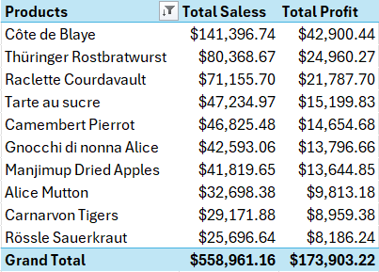
Côte de Blaye is the best-selling and most profitable product.
Thüringer Rostbratwurst and Raclette Courdavault also demonstrate strong sales and profitability.
On the other hand, Rössle Sauerkraut has the lowest sales and is the least profitable product.

4. Which products have a "reorder needed" status?
5. What is the percentage of Missing of Recorder Level?
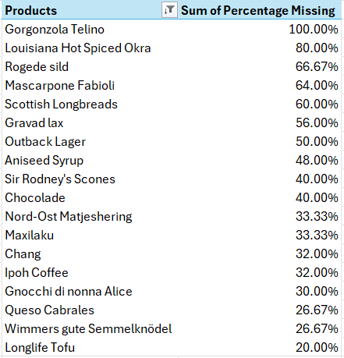
All products listed There are currently out of stock.
Gorgonzola Telino has a 100% reorder needed status, meaning it is completely out of stock and requires immediate replenishment from the supplier.
Louisiana Hot Spiced Okra and Rogede sild also have high missing percentages, indicating urgent reorder needs.
The Total Count of Missing Products are 18 Product.

Recommendations
- For Number of Products in Each Category (Confections, Beverages, Seafood, Condiments):
Focus on promoting and expanding the high-performing categories (Confections, Beverages, Seafood, Condiments) to maximize sales and profitability.
- For Top 10 Best-Selling Products (e.g., Côte de Blaye):
Increase marketing efforts and stock availability for top-selling products like Côte de Blaye, Thüringer Rostbratwurst, and Raclette Courdavault to maintain their strong performance.
- For Top 10 Most Profitable Products:
Prioritize the production and promotion of highly profitable products like Côte de Blaye and ensure they are always in stock to sustain revenue growth.
- For Products with "Reorder Needed" Status (e.g., Gorgonzola Telino):
Immediately contact suppliers to replenish out-of-stock products like Gorgonzola Telino, Louisiana Hot Spiced Okra, and Rogede sild to avoid lost sales.
- For Missing Reorder Levels (18 Products):
Implement a proactive inventory management system to monitor stock levels and reduce the number of missing products, ensuring timely recorders.

Geographical Insights
1. What are the total orders from each region?
2. What are the total orders from each Country?

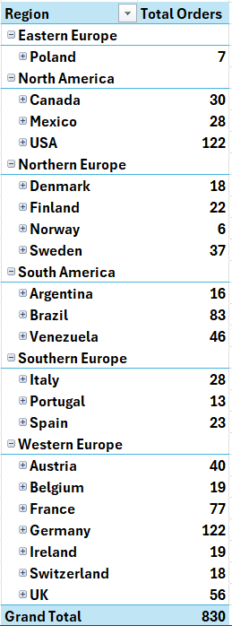
Orders are distributed across various regions and countries. Germany and the USA have the highest number of orders, with 122 each, while Norway and Poland have the lowest, with only 6 to 7 orders.

Recommendations
Focus on increasing marketing and sales efforts in Norway and Poland to boost order volumes in these underperforming regions. At the same time, maintain strong engagement strategies in Germany and the USA to sustain their high order numbers.

In conclusion, this report provides a comprehensive analysis of the Northwind data, highlighting key findings and actionable recommendations to enhance business performance.
However, the analysis process was not without its challenges, such as the complexity of joining multiple tables and cleaning the data to ensure accuracy.
Despite these difficulties, we were able to extract valuable insights that can support informed strategic decision-making. I hope this report proves useful and thank you for your trust.

Best regards,
Hossam Taha
LinkedIn

